**Numerical Computation - Assignment 5**

**薛劭杰 1930026143**

Q1.

Let $A =\left[\begin{matrix}1 & -1 & \begin{matrix}1 & 2\end{matrix} \\ 0 & 2 & \begin{matrix}1 & 0\end{matrix} \\ \begin{matrix}1 \\ 0\end{matrix} & \begin{matrix}3 \\ 2\end{matrix} & \begin{matrix}\begin{matrix}4 & 4\end{matrix} \\ \begin{matrix}1 & -1\end{matrix}\end{matrix}\end{matrix}\right]$, and decompose A into LU.

$⇒\left[\begin{matrix}1 & -1 & \begin{matrix}1 & 2\end{matrix} \\ 0 & 2 & \begin{matrix}1 & 0\end{matrix} \\ \begin{matrix}0 \\ 0\end{matrix} & \begin{matrix}4 \\ 2\end{matrix} & \begin{matrix}\begin{matrix}3 & 2\end{matrix} \\ \begin{matrix}1 & -1\end{matrix}\end{matrix}\end{matrix}\right]$ by $R_{3}-R_{1}$. $E_{1}=\left[\begin{matrix}1 & 0 & \begin{matrix}0 & 0\end{matrix} \\ 0 & 1 & \begin{matrix}0 & 0\end{matrix} \\ \begin{matrix}-1 \\ 0\end{matrix} & \begin{matrix}0 \\ 0\end{matrix} & \begin{matrix}\begin{matrix}1 & 0\end{matrix} \\ \begin{matrix}0 & 1\end{matrix}\end{matrix}\end{matrix}\right]$

$⇒\left[\begin{matrix}1 & -1 & \begin{matrix}1 & 2\end{matrix} \\ 0 & 2 & \begin{matrix}1 & 0\end{matrix} \\ \begin{matrix}0 \\ 0\end{matrix} & \begin{matrix}0 \\ 0\end{matrix} & \begin{matrix}\begin{matrix}1 & 1\end{matrix} \\ \begin{matrix}0 & -1\end{matrix}\end{matrix}\end{matrix}\right]$ by $R_{3}-2R_{1}$ and $R_{4}-R_{1}$ $E_{2}=\left[\begin{matrix}1 & 0 & \begin{matrix}0 & 0\end{matrix} \\ 0 & 1 & \begin{matrix}0 & 0\end{matrix} \\ \begin{matrix}0 \\ 0\end{matrix} & \begin{matrix}-2 \\ -1\end{matrix} & \begin{matrix}\begin{matrix}1 & 0\end{matrix} \\ \begin{matrix}0 & 1\end{matrix}\end{matrix}\end{matrix}\right]$

$U=\left[\begin{matrix}1 & -1 & \begin{matrix}1 & 2\end{matrix} \\ 0 & 2 & \begin{matrix}1 & 0\end{matrix} \\ \begin{matrix}0 \\ 0\end{matrix} & \begin{matrix}0 \\ 0\end{matrix} & \begin{matrix}\begin{matrix}1 & 1\end{matrix} \\ \begin{matrix}0 & -1\end{matrix}\end{matrix}\end{matrix}\right]$ and $U=E_{2}*E_{1}*A ⇒ A={\left(E_{1}\right)}^{-1} *{\left(E_{2}\right)}^{-1}*U$

So, $L={\left(E_{1}\right)}^{-1} *{\left(E_{2}\right)}^{-1}=\left[\begin{matrix}1 & 0 & \begin{matrix}0 & 0\end{matrix} \\ 0 & 1 & \begin{matrix}0 & 0\end{matrix} \\ \begin{matrix}1 \\ 0\end{matrix} & \begin{matrix}0 \\ 0\end{matrix} & \begin{matrix}\begin{matrix}1 & 0\end{matrix} \\ \begin{matrix}0 & 1\end{matrix}\end{matrix}\end{matrix}\right]*\left[\begin{matrix}1 & 0 & \begin{matrix}0 & 0\end{matrix} \\ 0 & 1 & \begin{matrix}0 & 0\end{matrix} \\ \begin{matrix}0 \\ 0\end{matrix} & \begin{matrix}2 \\ 1\end{matrix} & \begin{matrix}\begin{matrix}1 & 0\end{matrix} \\ \begin{matrix}0 & 1\end{matrix}\end{matrix}\end{matrix}\right]=\left[\begin{matrix}1 & 0 & \begin{matrix}0 & 0\end{matrix} \\ 0 & 1 & \begin{matrix}0 & 0\end{matrix} \\ \begin{matrix}1 \\ 0\end{matrix} & \begin{matrix}2 \\ 1\end{matrix} & \begin{matrix}\begin{matrix}1 & 0\end{matrix} \\ \begin{matrix}0 & 1\end{matrix}\end{matrix}\end{matrix}\right]$.

Q2.

Let $A =\left[\begin{matrix}4 & 2 & 0 \\ 4 & 4 & 2 \\ 2 & 2 & 3\end{matrix}\right], b=\left[\begin{matrix}2 \\ 4 \\ 6\end{matrix}\right]$, and decompose A into LU.

$⇒\left[\begin{matrix}4 & 2 & 0 \\ 0 & 2 & 2 \\ 0 & 1 & 3\end{matrix}\right]$ by $R_{2}-R_{1}, R_{2}-{\frac{1}{2}R}_{1}$. $E_{1}=\left[\begin{matrix}1 & 0 & 0 \\ -1 & 1 & 0 \\ -\frac{1}{2} & 0 & 1\end{matrix}\right]$.

$⇒\left[\begin{matrix}4 & 2 & 0 \\ 0 & 2 & 2 \\ 0 & 0 & 2\end{matrix}\right]$ by $R_{3}-\frac{1}{2}R_{2}$. $E_{2}=\left[\begin{matrix}1 & 0 & 0 \\ 0 & 1 & 0 \\ 0 & -\frac{1}{2} & 1\end{matrix}\right]$.

$U=\left[\begin{matrix}4 & 2 & 0 \\ 0 & 2 & 2 \\ 0 & 0 & 4\end{matrix}\right]$ and $U=E_{2}*E_{1}*A ⇒ A={\left(E_{1}\right)}^{-1} *{\left(E_{2}\right)}^{-1}*U$

So, $L={\left(E_{1}\right)}^{-1} *{\left(E_{2}\right)}^{-1}=\left[\begin{matrix}1 & 0 & 0 \\ 1 & 1 & 0 \\ \frac{1}{2} & 0 & 1\end{matrix}\right]*\left[\begin{matrix}1 & 0 & 0 \\ 0 & 1 & 0 \\ 0 & \frac{1}{2} & 1\end{matrix}\right]=\left[\begin{matrix}1 & 0 & 0 \\ 1 & 1 & 0 \\ \frac{1}{2} & \frac{1}{2} & 1\end{matrix}\right]$

Then $Ax=b ⇒LUx=b.$ Let $Ux=z$, then $Lz=b$.

$\left[\begin{matrix}1 & 0 & 0 \\ 1 & 1 & 0 \\ \frac{1}{2} & \frac{1}{2} & 1\end{matrix}\right]*z=\left[\begin{matrix}2 \\ 4 \\ 6\end{matrix}\right]$. Initialize them to a matrix $\left[\begin{matrix}1 & 0 & \begin{matrix}0 & 2\end{matrix} \\ 1 & 1 & \begin{matrix}0 & 4\end{matrix} \\ \frac{1}{2} & \frac{1}{2} & \begin{matrix}1 & 6\end{matrix}\end{matrix}\right]$

$⇒\left[\begin{matrix}1 & 0 & \begin{matrix}0 & 2\end{matrix} \\ 0 & 1 & \begin{matrix}0 & 2\end{matrix} \\ 0 & \frac{1}{2} & \begin{matrix}1 & 5\end{matrix}\end{matrix}\right]$ by $R_{2}-R_{1}$ and $R_{3}-{\frac{1}{2}R}_{1}$.

$⇒\left[\begin{matrix}1 & 0 & \begin{matrix}0 & 2\end{matrix} \\ 0 & 1 & \begin{matrix}0 & 2\end{matrix} \\ 0 & 0 & \begin{matrix}1 & 4\end{matrix}\end{matrix}\right]$ by $R_{3}-{\frac{1}{2}R}_{2}$.

Use the back substitution: $z_{3}=4, z_{2}=2, z_{1}=2$

$Ux=z⇒\left[\begin{matrix}4 & 2 & 0 \\ 0 & 2 & 2 \\ 0 & 0 & 2\end{matrix}\right]*x=\left[\begin{matrix}2 \\ 2 \\ 4\end{matrix}\right]$. Initialize them to a matrix $\left[\begin{matrix}4 & 2 & \begin{matrix}0 & 2\end{matrix} \\ 0 & 2 & \begin{matrix}2 & 2\end{matrix} \\ 0 & 0 & \begin{matrix}4 & 4\end{matrix}\end{matrix}\right]$.

Use the back substitution: $x_{3}=2, x_{2}=\frac{2-\left(2*2\right)}{2}=-1, x_{1}=\frac{2-2*(-1)}{4}=1$,

Q3.

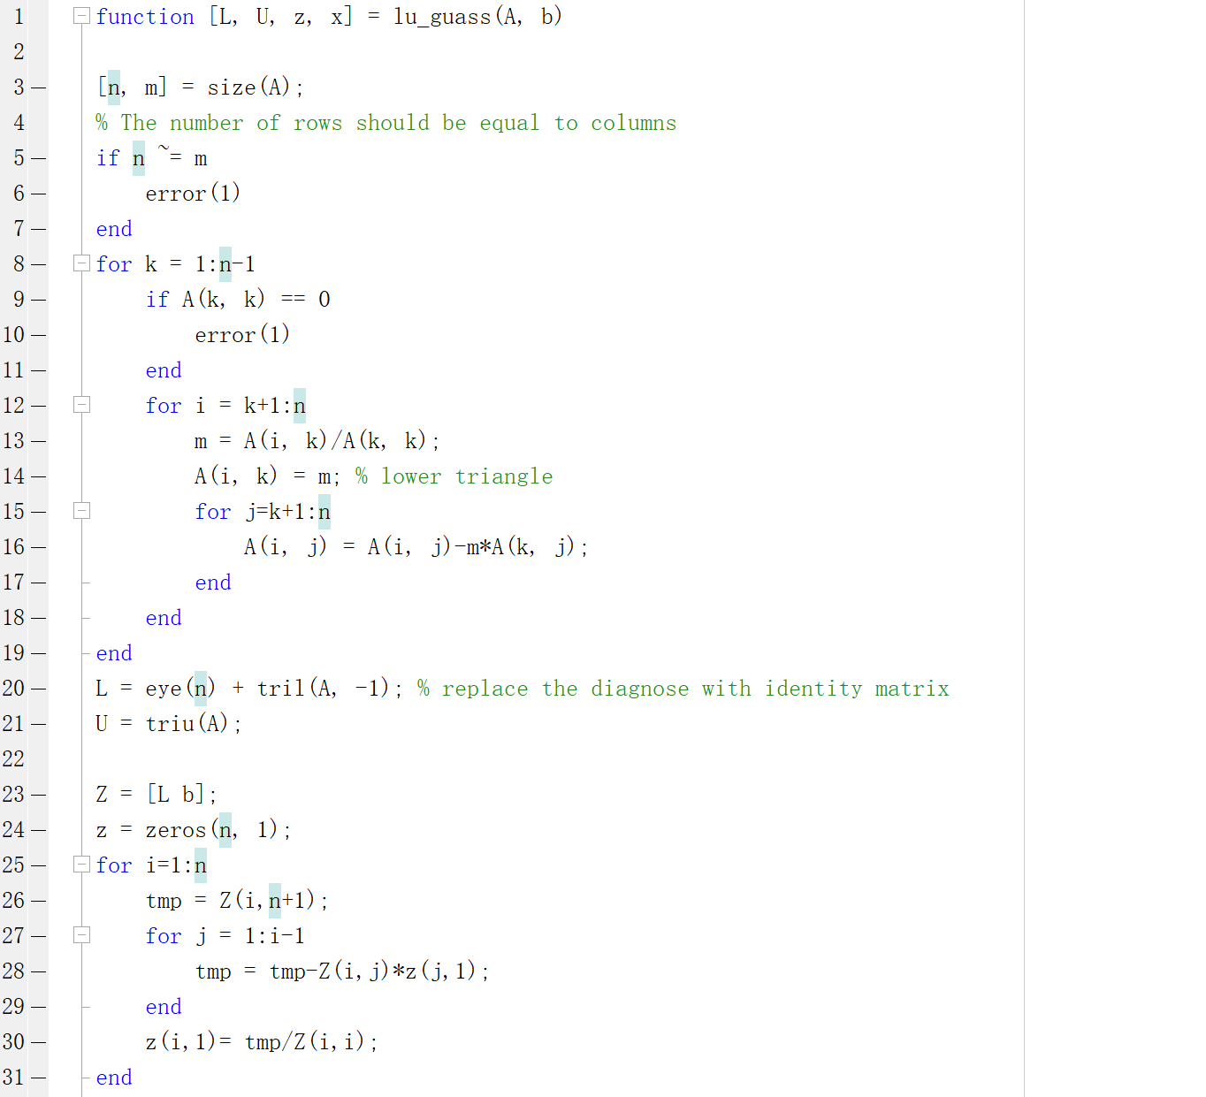

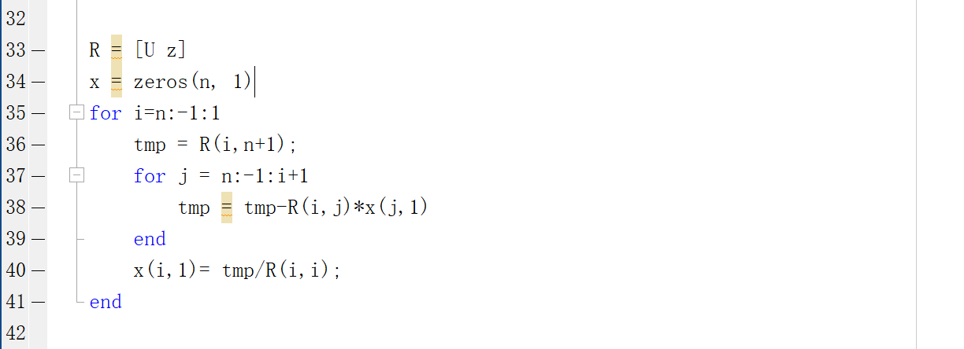

The code in the red box is modification (addition) part.



Q4.

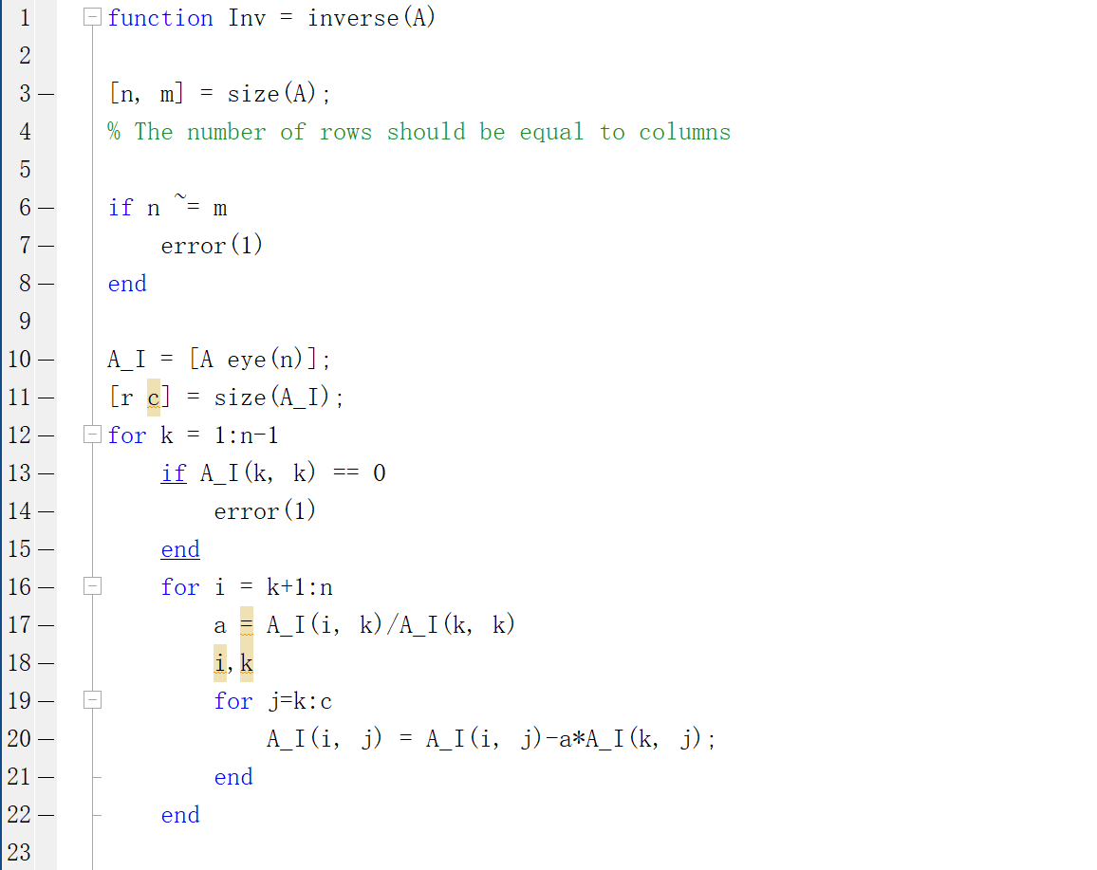

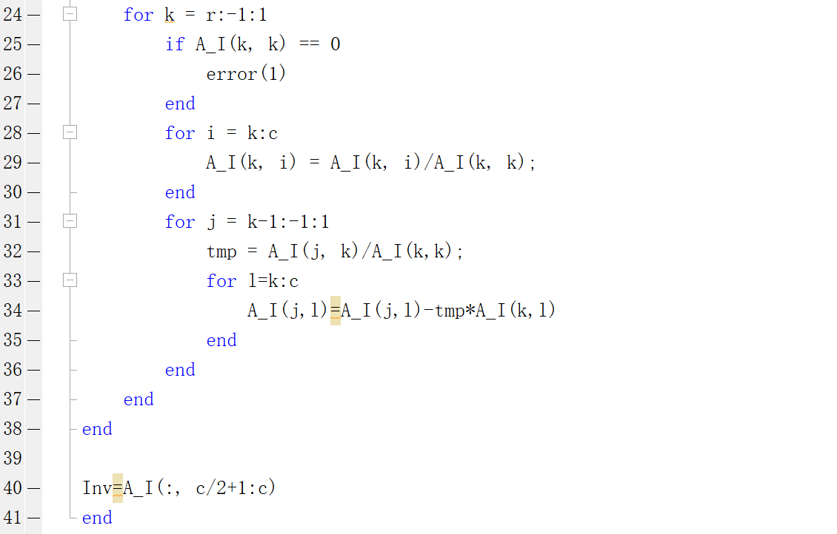

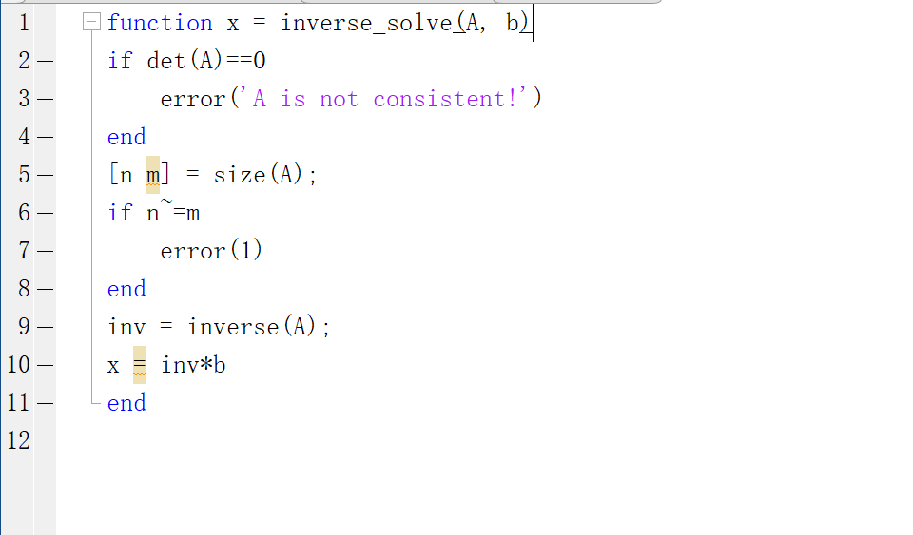

Q5.

The result of the $lu_guass()$ method in question 3:

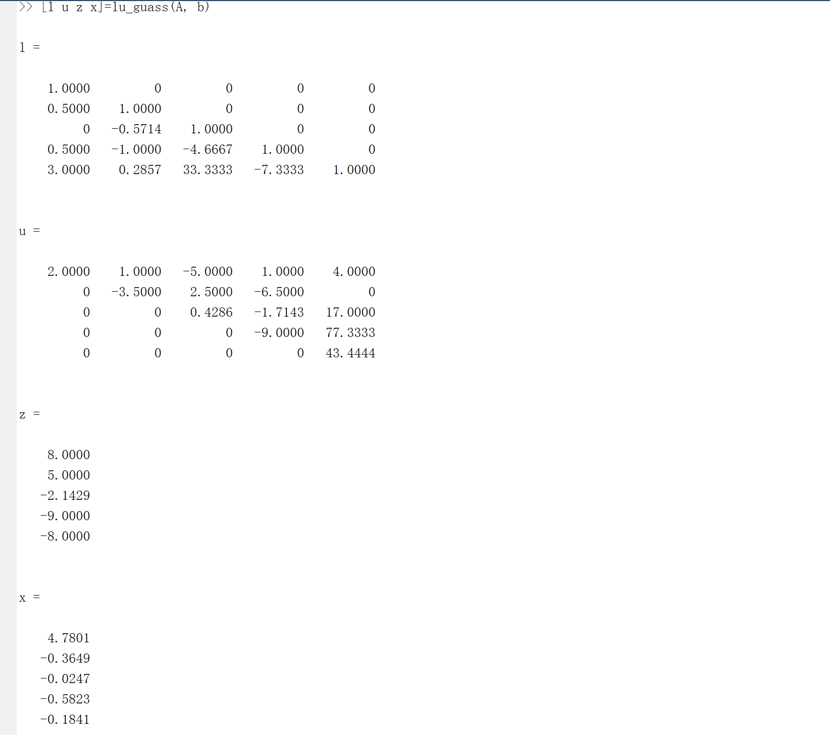

The result of the $inverse_solve()$ method in question 4:

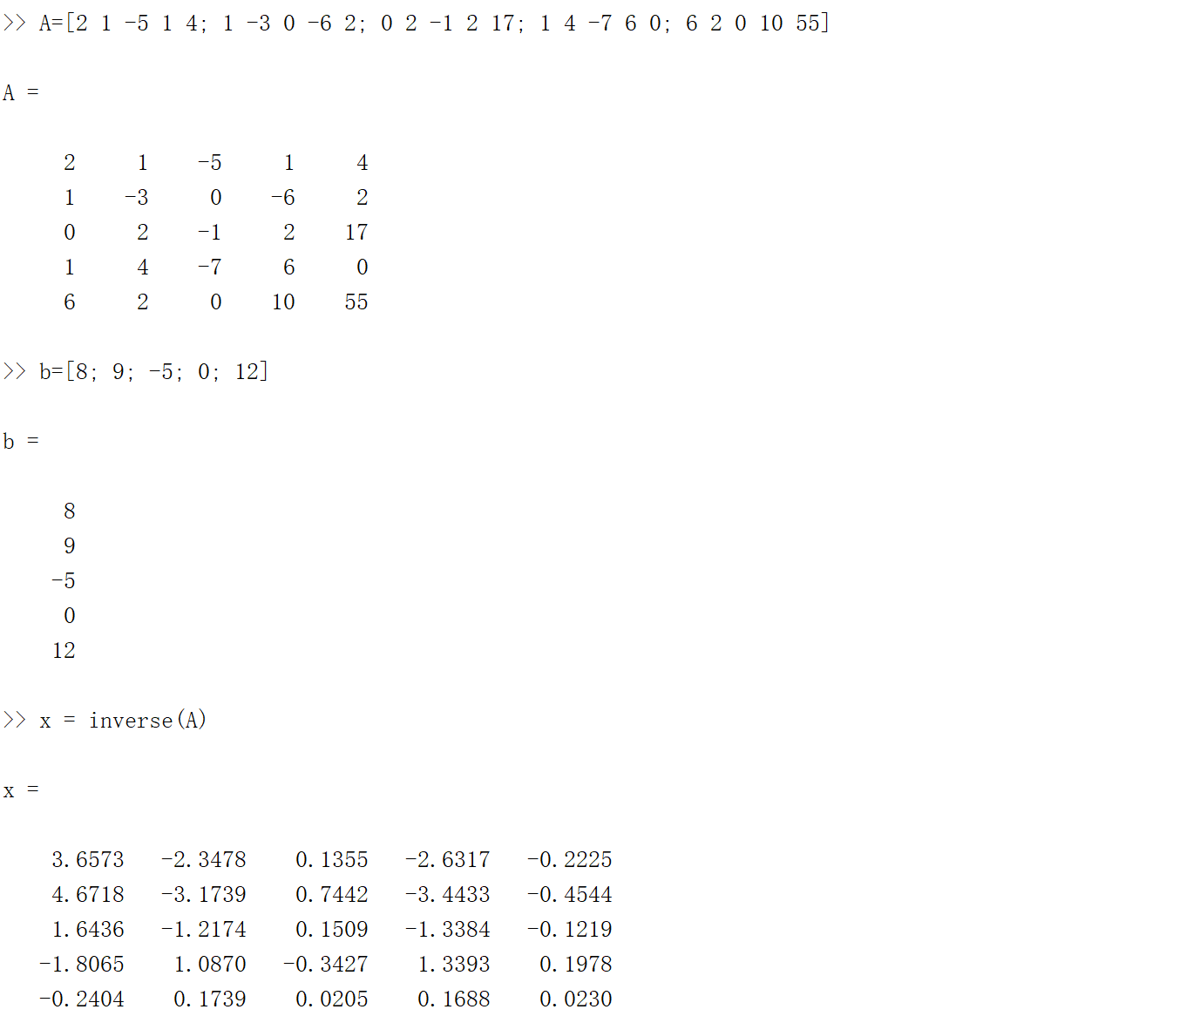

Q6.

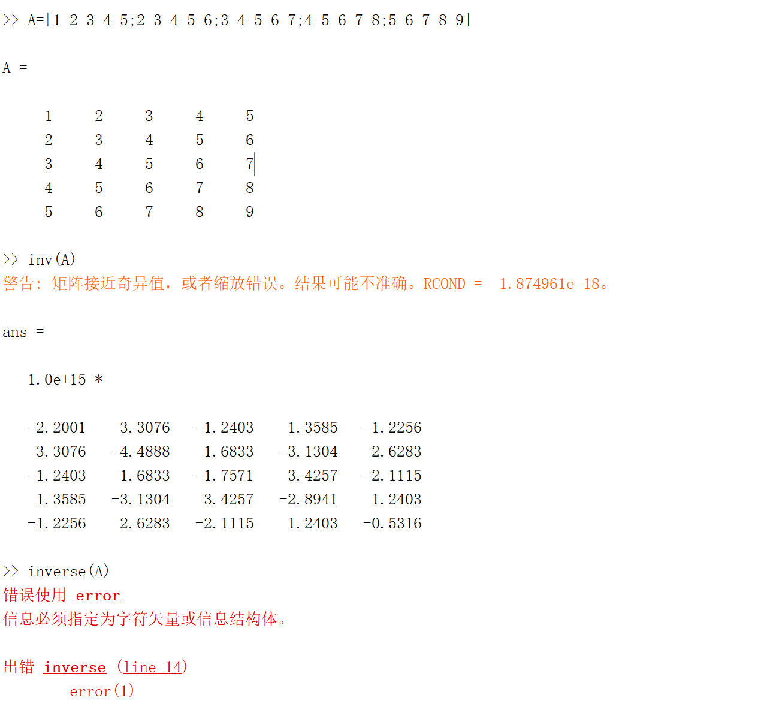

The result of direct $inv(A)$ and the function in Q4 $inverse(A)$ are not same. Because in the $inverse()$  
, we determine whether the input matrix is consistent or not. In the print screen we can see it catch this error. So, there are some differences between them.